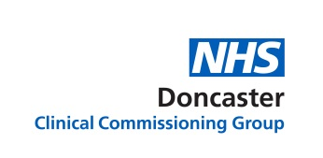
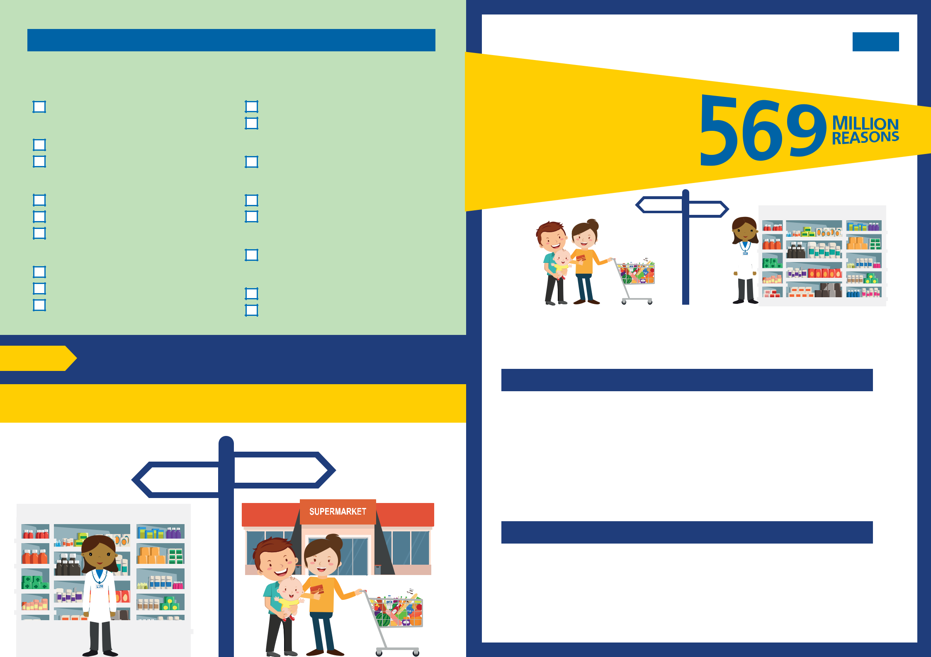
Self limiting conditions – should get better on their own

- These items are only available from your pharmacy
.

Cold sores (on the lips)

Aciclovir cream

Conjunctivitis (Bacterial)

Eye bath/wash

Chloramphenicol drops (2yrs+) +

Constipation

Bisacodyl

Senna

Docusate

Coughs, colds and nasal congestion

Cough mixtures

Decongestant nose drops/spray Cold/flu capsules/sachets

Cradle cap

Emulsifying ointment +

Shampoos

Cystitis (mild)

Cystitis relief sachets

Haemorrhoids

Creams/ointments

Suppositories

Infant colic

Simethicone suspensions

Sore throat

Benzydamine throat spray +

Lozenges

GP practices NO LONGER

provide prescriptions for

medicines that you can

buy at the pharmacy,

supermarket or

elsewhere.
SUPERMARKET | PHARMACY | + PHARMACY
FEVER

Take this form to your pharmacy or supermarket to buy the
Next step recommended product(s). If after treatment you do not feel better

please seek further medical advice.

Be prepared! Keep this leaflet in a safe place so you can save yourself time and refer to it in the future, without the need to visit the GP practice.

SUPERMARKET
PHARMACY

+ PHARMACY

F E V E R

In 2017 the NHS spent approximately £569million on Over the Counter (OTC) medicines in England. This is money that could be used to support more serious and/or long-term health conditions.

What has changed?

Some medicines, that are available to buy OTC from pharmacies and supermarkets, are no longer prescribed by GP practices. GP practices will advise patients to buy these medicines OTC.

The medicines affected are those used to treat minor, short-term health conditions, which:

- you can easily treat yourself (self-care) or
- should get better on their own (self-limiting)

This change applies to OTC medicines for the conditions listed in this leaflet.

Why did we make these changes?

In March 2018, following national public consultation, NHS England published national guidance on reducing the prescribing of OTC medicines for minor, short-term health conditions.

It costs the NHS much more to prescribe these medicines on a prescription than if they are bought OTC. This is because the NHS has to pay extra fees for the medical consultation(s) and for the pharmacy to supply them.

What if I am exempt from paying prescription charges?
This guidance applies to ALL patients, including those who are exempt from paying prescription charges.

Where can I buy these OTC medicines?
These can be purchased without the need for a prescription from pharmacies, supermarkets and other retail outlets.

How much do OTC medicines cost?
Just like with other goods, the price of medicines may vary between retailers so it is a good idea to shop around to get the best value.

The average cost of most of these medicines will be around £2 to £3 and some will be even cheaper. A minor ailment scheme to obtain some medicines for minor ailments with no upfront charge is available at participating pharmacies for those who normally have help with their prescription charges.

What if I need my medication labelled?

Schools, holiday clubs, carers, etc. may require medicines to be supplied with labels on them. Some pharmacies may label medicines purchased OTC for you. Ask at your pharmacy.

Care navigation – right care, first time
Your GP practice receptionist may advise you to visit the pharmacy first. If you have already spoken to a pharmacist and tried OTC medicines, please bring these with you to your appointment.

Where can I get further advice?
Community pharmacies play a key role in advising patients on minor conditions that you can treat yourself. They are experts on medicines and can signpost to other services if needed.

Most pharmacies have a quiet area, away from other customers, where you can speak to a pharmacist in private. You don't need an appointment, you can just walk in. Many pharmacies also have extended opening hours, including evenings and weekends.

To locate your nearest community pharmacy visit the NHS website: www.nhs.uk/service-search

No prescription required - Referral to local pharmacy

You have a common condition that does not require treatment or can be treated with a medication that is available to buy over the counter.

Please visit your pharmacist for help and advice. You do not need to make an appointment to speak to the pharmacist, just pop in anytime.

Your pharmacist can give you help and advice on the most appropriate medication to relieve your symptoms for:

 | Acute sore throat |  |  | Insect bites and stings
 | Cold sore |  |  | Mild acne
 | Conjunctivitis |  |  | Mild dry skin
 | Coughs and cold |  |  | Sunburn (and sun protection)
 | Cradle cap |  |  | Mild hayfever
 | Haemorrhoids |  |  | Minor burn or scald
 | Infant colic |  |  | Pain and/or fever
 | Mild cystitis |  |  | Mouth ulcer
 | Mild dermatitis |  |  | Nappy rash
 | Dandruff |  |  | Oral thrush
 | Diarrhoea (adults only) |  |  | Ringworm or athletes foot
 | Dry or sore eyes |  |  | Teething or mild toothache
 | Earwax |  |  | Threadworms
 | Excessive sweating |  |  | Travel sickness
 | Head lice |  |  | Warts and verrucae
 | Indigestion and heartburn |  |  | Other - please indicate
 | Infrequent constipation
 | Infrequent migraine

If at any time you are concerned about your condition or if your symptoms are not improving after a few days of treatment with the over the counter medications you should contact the local pharmacist or the surgery for more advice.

